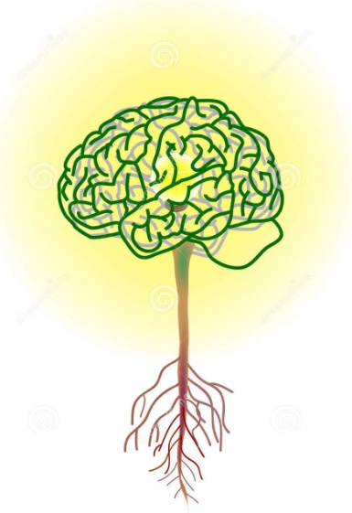 | AP / IB Psychology Syllabus  & Brief Overview  Instructor:  Mr. Kyle T. Austin  kyle.austin@sumterschools.net  kyletaustin@gmail.com  School: Sumter High  Room: D 111  Year: 2018-2019

Psychology is most appropriately defined as the systematic study of behavior and experience. Its historical development, however, has witnessed several difficulties in arriving at a precise clarification of its subject matter and methodological focus. In the 19th century, psychology began to emerge from its ties with philosophical speculation. In the 20th century the main focus was on empirical and scientific research methods. The current trend is towards a balance or quantitative and qualitative methods. Without denying its historical links with other fields of inquiry, modern psychology occupies an important position as a meeting ground for both the natural and the social sciences. The variety of current research areas and applications reflect the prominent role or psychology in modern society. In recent years great attention has been given to cultural variables to study the diversity of human behavior in a more comprehensive way. Whatever their background or methodology, psychologists employ rigorous procedures throughout the research process, utilizing their findings for the possible improvement of individual life as well as for the understanding of the social conditions that affect the individual.

IB - Standard Level
Psychology and the international dimension
IB psychology takes a holistic approach that fosters intercultural understanding and respect. In the core of the IB psychology course, the biological level of analysis demonstrates what all humans share, whereas the cognitive and sociocultural levels of analysis reveal the immense diversity of influences that produce human behavior and mental processes. Cultural diversity is explored and students are encouraged to develop empathy for the feelings, needs and lives of others within and outside their own culture. This empathy contributes to an international understanding.
Psychology SL IB assessment.
SL students are assessed on the levels of analysis in paper 1. In addition:
• SL students are assessed on their knowledge and comprehension of one option in paper 2,
• in the internal assessment, the report of a simple experimental study conducted by SL students requires quantitative statistical analysis.

No prior study of psychology is expected. No particular background in terms of specific subjects studied for national or international qualifications is expected or required of students. The skills needed for the psychology course are developed during the course itself.

Assessments: Students will be assessed with quizzes, chapter tests, midterm test, class/home work, experiment reconstruction, projects as assigned.

Tests: 30%
Quizzes 25%
Class work / Homework are 20%
Projects 25%

Some tests will mimic AP format with multiple choice and free response questions, other tests will mimic IB tests which will be free response questions.

Textbooks & Resources:
- Crane, John & Jette Hannibal, 2012. Psychology: course companion. Oxford U Press.
- Garrod, Andrew et al. 2008. Adolescent Portraits 6th ed. Boston, Pearson Publishing.
- Myers, David G, 2006. Psychology 8th ed. New York, Worth
- Teacher created booklets with selected readings in each of the Psychological Level of analysis these include, Biological Level of analysis articles collected from Scientific America (such as Teicher, 2002, The Neurobiology of Child Abuse and Nestler & Malenka, 2004, The Addicted Brain) and the Annual Review of Psychology; Cognitive Psychology articles collected on Ebbinghaus, Memory, Loftus, from The Psychologist, etc.; Learning Level of analysis articles collected from psychclassics.asu.edu such as Watson’s article on Behavior and the Concept of Mental Disease.
- Schwartz, Steven,1986, Classic Studies in Psychology, Queensland, Australia, Mayfield Publishing

- Students are expected to have a 3 ring binder with dividers to keep all handouts, papers and articles in.

COURSE OVERVIEW:

IB Standard Level (required elements): | AP (required elements):
Levels of Analysis (compulsory) | History of Psychology/Perspectives in Psychology
- The biological level of analysis | Psychological Research
- The cognitive level of analysis | Biological aspects
- The Socio-cultural level of analysis | Nature/Nurture-Human Diversity
Options (Out of seven available options) | Human Development
- Abnormal Psychology | Sensation & Perception
- Human Development | States of Consciousness
Research Methodology (compulsory) | Learning & Conditioning
- Ethics | Memory
Quantitative research methods | Cognition
Simple Experimental Study *** | Intelligence
 | Motivation & Emotion
 | Stress & Health
 | Personality
 | Abnormal Psychology-Disorders & Therapy
 | Social Psychology

*** 1 Simple Experimental Studies
•Students are required to plan and undertake One simple experimental study, and to produce a lab report of their study. A simple experimental study involves the manipulation, by the student, of a single independent variable and the measurement of the effect of this independent variable on a dependent variable, while controlling other variables. The experiment will be preapproved and implemented with guidance from the teacher.

In addition to the Major Experimental Study students will also conduct:
Interviews
• Evaluate semi-structured, focus group and narrative interviews.
• Discuss considerations involved before, during and after an interview (for example, sampling method, data recording, traditional versus postmodern transcription, debriefing).
• Explain how researchers use inductive content analysis (thematic analysis) on interview transcripts.
Case studies
• Evaluate the use of case studies in research.
• Explain how a case study could be used to investigate a problem in an organization or group (for example: a football team, a school, a family).
• Discuss the extent to which findings can be generalized from a single case study.

Topics of Psychology in Order as we cover them:
(Dates are subject to change as needed)
History of Psychology/Perspectives in Psychology (AP) | Week 1 & 2
Psychological Research (AP & IB) | Week 3 & 4
---I.A. Development --- | Week 5
The Biological Level of Analysis (IB) | Week 6 & 7
Human Development (AP & IB) | Week 8 & 9
Sensation & Perception (AP) | Week 10
Learning & Conditioning (AP & IB) | Week 11 & 12
Memory (AP & IB) | Week 13
The Cognitive Level of Analysis (IB) | Week 14 & 15
The Socio-cultural Level of Analysis (AP & IB) | Week 16 & 17
Abnormal Psychology-Disorders & Therapy (AP &IB) | Week 18 & 19
Review | Remanding time

