SHS IB Language Policy

The purpose of this policy is to describe for all stakeholders the principles and practices for achieving our goals for language teaching and learning regarding all aspects of Language support for the Sumter High School International Baccalaureate Diploma Program.

1.Philosophy

We view the on-going language development for our students as the shared responsibility of all teachers, parents, and students, understanding that all students progress at different rates. We acknowledge that the implementation of effective pedagogy depends on whole-school collaborative practices that support our principles and goals. We value learner diversity, and we recognize that language is a part of learner identity and can serve as a source of empowerment. We believe that the practices for language development are a part of inclusion and equity provision. All teachers are language teachers, facilitating communication. We all are responsible for supporting language acquisition, for ensuring that all students use language responsibly, and for teaching and learning in ways that promote literacy in the languages of the disciplines of the coursework of our International Baccalaureate Diploma Program (IB DP).

A student’s ability to communicate in a variety of ways in more than one language is essential, especially when encouraging students to develop the attributes of the IB Learner Profile. We agree with the IBO position: “multilingualism for all students is an essential characteristic of an IB education” (Diploma Program: From Principles to Practice, 2015). We believe that language is learned through a progression of understanding from infancy into adulthood. Initially, a child’s understanding may be symbolic in nature (learning language). In time the child uses his or her understanding to interact socially such as in a school setting. From this point the child will develop basic literacy skills. In time, the child will use language to further learning (learning through language), and eventually, will construct knowledge (learning about language) (Learning in a Language other than Mother Tongue in IB Programmes, 2008).

Further, we believe that all students should have the opportunity to experience learning additional languages, which provides significant experience in international education, enabling students to understand the thinking and culture of others. Through effective communication in another language, students are sensitized to cultural diversity and better able to understand the global world in which they live, preparing them to be active participants in multilingual communities at home and around the world. Furthermore, our IB DP community establishes an environment that values all languages and cultures and seeks to promote international-mindedness.

Language Profile
In our context, (United States) the language of the host country is English. This is our language of teaching and learning in nearly all IB courses in our school’s IB Diploma Programme. The exceptions are our Group Two subjects wherein the languages of instruction will be the language being acquired and English. Our school is situated in a small city in the state of South Carolina. There are speakers of languages other than English in our community partly because there is a large air force base located here. As a result, Sumter High School currently has an enrollment whose language profile follows.

· English only background students with no Language B proficiency
· English only background students with minimal Language B exposure through limited
middle school experience
· Bi-lingual Hispanic and Asian students who have acquired both languages simultaneously
since birth

· Bi-lingual Hispanic and Asian students whose parents speak no English but are English
proficient as a result of attending school

The IB Diploma program has the following language profile.
- English only background students with little or no Language B proficiency.
- Bi-lingual students whose parents speak limited or no English but the students are English proficient as
a result in part of attending school.

2. Practices

English is the language of instruction at Sumter High School and admissions requirements and assessments are conducted to ensure that students can access the curriculum delivered in English. To that end all students in the IB Diploma Program are required to take English A1 Higher Level as their Language A. Students are expected to produce their assessments in the working language of our IB DP (English). Language learning requires development of both receptive (listening and reading) and productive (speaking and writing) skills, which can be transferred from one language to another. The study of literature is widely recognized as a means to explore other cultures. Interpretation, multiple readings, and a consideration of cultural contexts require a study of word choice, symbolism, metaphoric imagery, and their associated values.

Academic Literacy
One of our goals in language development is for IB DP students must become fluent in the academic languages of several academic disciplines. The academic literacy skills students acquire will allow them to be part of interactive dialogs, actively decode academic texts, and write complex texts for a variety of academic purposes and audiences (for example, lab reports and Extended Essays). All teachers are responsible for the teaching and learning of the language necessary for understanding in their academic discourse (for example, the language of biology or mathematics), thereby learning to use language as a scientist or mathematician does. This is not limited to simple vocabulary development but expands to manipulation of that language and critical evaluation of the use of that language by others.

We teach language through context and relate new information to existing knowledge. Students learn and transfer the knowledge (often through their study of an additional language) that spelling matters. For example, a missing accent mark may make the difference between two completely different words in a language. Therefore, we emphasize the value of spelling in all IB coursework. Teachers have discretion in weighting spelling in the scheme of the overall marking of assessments for their coursework. Teachers instruct students in appropriate referencing protocols for resources, and students are expected to follow the protocols in place.

A student’s skills and knowledge in all their languages is recognized by teachers as a valuable resource and is used in teaching and learning new ways of thinking and knowing (for example, by analogy: this is like that in science class.) Teachers activate students’ prior knowledge in order to build upon it. Our IB DP Teachers are aware of their students’ language abilities and scaffold instruction appropriately, using temporary strategies so that students may accomplish tasks that would otherwise be much more difficult (Developing Academic Literacy in IB Programmes, 2014). Teachers may use strategies such as visual aids, graphic organizers, demonstrations, and/or collaborative grouping in their efforts to scaffold teaching and learning.

In our IB DP, reading and writing matter. Students will need to read and understand sophisticated texts both inside and outside of the classroom. Students will need to write in a wide range of genres (narratives, reports, explanations, arguments, discussions, etc.). These skills will transcend traditional contexts into areas of media literacy, as well. The academic language of the texts students will encounter will show the complexity and abstraction of concepts students are required to understand. There will be an increase in the occurrence of low-frequency and technical vocabulary and likely more sophisticated grammatical constructions.

We strive towards critical literacy for our IB students. This requires their being able to critique all texts, whether written or oral, paying attention to the way in which language and its constructs is used to define truth, fact, and reality. Critical literacy is important in students’ developing intercultural awareness and international-mindedness is a part of all subject areas in our IB DP.

Professional development in linguistics is available such that our teachers may be trained in best practices for developing academic language and for supporting students whose mother tongue is not English. Professional development raises awareness of how language and thinking are interconnected.

Acquiring an Additional Language

Languages ab initio
Beginning with the ninth grade year, students may choose to study an additional language, either Spanish or French. This decision is made collaboratively with the student, parents, and counselor. In the IB Diploma Program students must take one subject from Group Two, where we offer Language ab initio in French or Spanish. Typically those students who have taken a minimum of three courses prior to entering the IB will take the B level of the language. The teachers of these courses collaborate with the students and their parents in determining the level of acquisition and proficiency for their students and the appropriate course level. The Language ab inito courses are taught over a two year period.

Inclusion and Equity of Access for Students Whose Mother Tongue is Not English
(Mother Tongue Development and Maintenance)
We acknowledge the importance of a student’s Mother Tongue in promoting personal identity and maintaining cultural heritage. We do not currently have in place formal support for the preservation and development of a person’s mother tongue if it is not English (other than in our Language B and ab initio courses). However, in the event that a student, whose mother tongue was not English, desired to participate in our IB DP we would collaborate with school personnel and the community to try to offer a school-supported self-taught option in Group 1. We may then offer English or another language ab inito or B as additional language learning options. At this time, no student has made this request. We offer support in our Language B and ab initio target languages through after school tutoring sessions on a drop-in basis. We provide culture-specific identity support in after school clubs such as Spanish Club, French Club, and the African-American Heritage Club. Further support for non-English proficient students is offered by the Sumter County School District as follows.

District Policy
Our IB DP falls under the authority of our school (Sumter High School), and our school falls under the authority of our school district (Sumter School District). Policies and guidelines designed to meet legal requirements are developed at the district level and are outside of the control of the IB DP and are included here.

Our district uses the acronym MLP (Multilingual Learner Program) to refer to the program that identifies and serves the linguistic and academic needs of students who enter our schools with limited English proficiency. These students are protected by the Civil Rights Act of 1964. They are entitled to equal education regardless of their national origin, English proficiency or immigration status.

Identification
The test we use to screen and identify students is the World-Class Instructional Design and Assessment (WIDA) screener. Students who have a composite score below 4.4 and do not obtain a 4 in each domain are eligible for MLP services and are placed in the program.

Initial grade placement should be with the same age classmates. Classroom teachers should modify instruction and assignments to meet the academic and language needs of MLs. Grades should reflect these modifications.

MLs at Sumter High School are served through a pull-out model. Students with lower proficiency levels are seen 2-3 times a week. The class size is small which provides a comfortable and focused environment for MLs students to improve English proficiency. The MLP teacher incorporates activities weekly to improve each student’s reading, writing, speaking, and listening proficiencies.

The district acknowledges that having MLs in a class can provide an interesting multicultural learning environment in which all benefit. Teachers are reminded that MLs can and should be referred for Gifted and Talented as well as advanced courses. Language barriers should not prevent them from participating and succeeding in higher level programs.

Goals
The goal of Sumter School District’s ML Program is to provide equal educational opportunities to students who have a primary or home language other than English and who are Limited English Proficient (LEP) or Non-English Proficient (NEP). The primary focus is to provide an English-rich environment so those students will become proficient in English as soon as possible. The district strives to create a learning environment that encourages student pride in their cultural heritage and provides the cognitive and affective support to help students become contributing members of society. This program, beginning in kindergarten and continuing through high school, will provide these students the opportunity to be successful in academic areas and to develop listening, speaking, reading and writing proficiency in order to be successfully mainstreamed into all classes.

Grades and Grading Systems
Content area teachers should make accommodations in instruction and assignments based on student fluency levels, and assessments should be based on these accommodations. Grades should reflect students’ participation, effort, and progress. Teachers are encouraged to confer with ESOL teachers about specific students. Decisions such as grade retention or failure in classes should be made in conference with ESOL teachers, the building principal, guidance counselor, and other professionals. Whenever possible, students should be promoted along with age-level peers.

Traditional procedures for assigning grades to students may not be appropriate for MLs. The same methods and criteria applied to their English-speaking age and /or grade peers cannot always be used to assess students who lack English language proficiency. Teachers should be encouraged to maintain high expectations for student learning and should accommodate and adapt lessons and assignments so that MLs can progress. Likewise, assessments should be modified so that students can demonstrate their knowledge and skills. The LEA (Local Education Agency) must describe their grading policies and procedures in local ML plans and should provide training for appropriate personnel so that the policies and procedures are implemented consistently and fairly. The key to appropriate grading of MLs is appropriate instructional accommodations. Even non-English proficient students can learn content while acquiring English. If content teachers are unsure how to accommodate MLs, they should consult with the Multilingual Learner Program Specialist and may also seek additional in-service training. A student may not be assigned a failing grade in a content area on the basis of lack of English language proficiency.

English Proficiency Levels

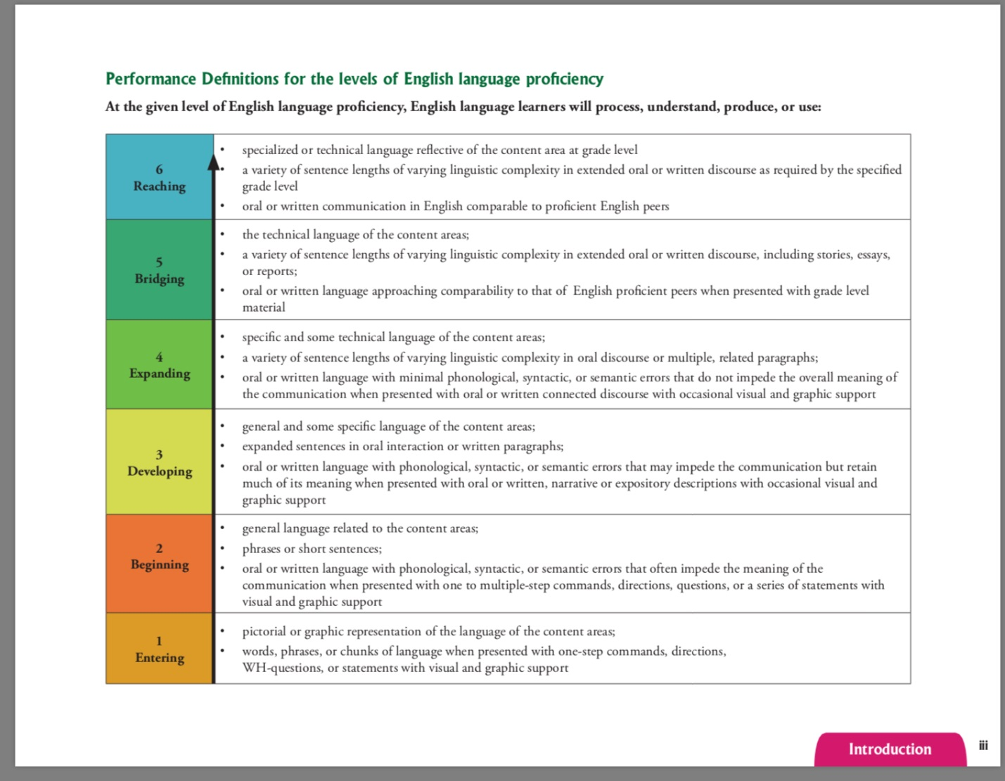

Communicating with Parents
The school district provides all schools an automatic translating service, Tele-interpret, by phone. Teachers are encouraged to use this program for parent-teacher conferences. If the family does not have an interpreter or translator, it is the responsibility of the student’s school staff and/or administration to secure one. Where applicable, teachers are to use translations of routine school-parent communication, such as report cards, health forms, interim reports, field trip permission forms, free lunch eligibility forms, etc. Academic Plan conferences are required for all students who score below basic on PASS (Palmetto Assessment of State Standards) and SC Ready. If parents are non-English speaking, they may need an interpreter.

IB Requirements
As articulated in the Programme standards and practices, the following practices require schools to demonstrate their support of language and learning in the IB.
- Culture 4.1: The school implements and reviews a language policy that is aligned with IB language policy guidelines.
- Culture 4.2: The school describes in its language policy the way that the school recognizes multilingualism as a fact, a right, and a resource for learning.
- Culture 4.3: The school identifies in its language policy a variety of physical and virtual resources used to facilitate language development.
- Culture 4.4: The school clearly describes in its language policy the rights and responsibilities of all members of the school community and clearly states the school’s vision for implementing inclusive programmes.
- Lifelong learners 7.1: The school provides opportunities for students to explore and develop their personal and cultural identities.
- Lifelong learners 7.2: The school community affirms individual student identity through learning and teaching.
- Lifelong learners 7.3: Students take opportunities to develop their language profiles.
- Approaches to teaching 5.4: Teachers support language development with consideration for the language profiles of students.

3. Links to Inclusive Education, Language, Academic Honesty, and Admissions Policies

Language and Inclusive Education
In the IB DP of Sumter High School students for whom English is not their native tongue or who require learning support may expect that teachers will use teaching and learning strategies designed best to accommodate students with particular inclusive education needs.

Language and Assessment
Students identified as additional language learners of English in our school are encouraged to participate in our IB DP. Students, their parents, and language support teachers are responsible for informing the IB classroom teachers and coordinator of the enrollment of additional language learners in the DP. Teachers differentiate their assessments to meet the needs of all language learners.

Language and Academic Honesty
Teachers stress the value of language and of ownership in language production. In support of this, they provide instruction to IB DP students on appropriate effective citing and referencing. Teachers provide explicit instruction regarding the degree of help outside of the student’s own knowledge and skill base that will be allowed for each assessment. Expectations regarding academic integrity are clearly communicated and authentic student work is highly regarded. Consequences for misconduct are clearly communicated.

Language and Admissions
While our Admissions Policy stipulates that students must have no grade lower than “70” for any prerequisite course, circumstances will be taken into consideration where a students’ performance showed improvement over time even if the final mark for the course does not reflect this growth. It is the assessment of the student’s readiness, willingness, and work ethic which eclipse past academic performance. In such cases, the IB teacher of the given course will conduct an interview with the student to determine the student’s understanding of the whole course in question. Language needs will in no way hinder a student’s admission into the IB DP of Sumter High School.

4. The Implementation, Evaluation, and Review of the Language Policy

Training Teachers new to the IB Program
The IB Coordinator, any course veteran(s), and new teacher(s) will meet within the first few weeks of the start of the school year in a small group or one-on-one training session following the sharing of the policy with the IB Faculty.
Communication and Review of the Language Policy
Annually, the IB Faculty and administration will receive the latest draft from the IB Coordinator for their review. They may email their questions and concerns to the coordinator for discussion at IB Faculty meetings of the school year. Changes will be made by consensus of those present at that meeting.

Annually, IB Students and their parents will receive written copies of the policy within the IB student handbook within the first month of the school year. Students and their parents will be solicited for their input for any revision(s) that may be needed.

Other IB stakeholders may view the policy any time online on the school’s IB website. Questions, comments, or concerns may be emailed to the IB coordinator who will forward them to the Language Policy Committee, comprised of 2 Teachers, 1 Parent, 1 Student, Librarian, and the ESOL Teacher. Decisions and recommendations are based on criteria related to impact, access and quality, as well as, consideration on viability and sustainability (Language and Learning in the IB Programmes, 2014).

References and Resources

Developing Academic Literacy in IB Programmes. Online. Programme Resource Centre. International

Baccalaureate Organization, 2014.

Diploma Programme: From Principles to Practice. Online. Programme Resource Centre. International

Baccalaureate Organization, 2015.

Guidelines for Developing a School Language Policy. Online. Programme Resource Centre. International

Baccalaureate Organization, 2008.

Guidelines for School Self-reflection on its Language Policy. Online. Programme Resource Centre.

International Baccalaureate Organization, 2012.

Language and Learning in IB Programmes. Online. Programme Resource Centre International

Baccalaureate Organization, 2014.

Learning in a Language Other than Mother Tongue in IB Programmes. Online. Programme Resource

Centre. International Baccalaureate Organization, 2008.

Programme Standards and Practices. Online. Programme Resource Centre. International Baccalaureate

Organization, 2023.

