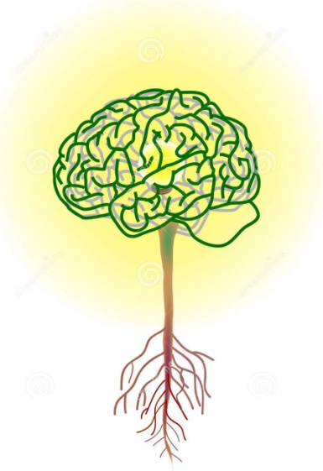 | IB Psychology SL Syllabus  & Brief Overview  Instructor:  Mr. Austin  kyle.austin@sumterschools.net  School: Sumter High  Room: D111  Year: 2023-2024

Psychology is most appropriately defined as the systematic study of behavior and experience. Its historical development, however, has witnessed several difficulties in arriving at a precise clarification of its subject matter and methodological focus. In the 19th century, psychology began to emerge from its ties with philosophical speculation. In the 20th century the main focus was on empirical and scientific research methods. The current trend is towards a balance or quantitative and qualitative methods. Without denying its historical links with other fields of inquiry, modern psychology occupies an important position as a meeting ground for both the natural and the social sciences. The variety of current research areas and applications reflect the prominent role or psychology in modern society. In recent years great attention has been given to cultural variables to study the diversity of human behavior in a more comprehensive way. Whatever their background or methodology, psychologists employ rigorous procedures throughout the research process, utilizing their findings for the possible improvement of individual life as well as for the understanding of the social conditions that affect the individual.

IB - Standard Level
Psychology and the international dimension
IB psychology takes a holistic approach that fosters intercultural understanding and respect. In the core of the IB psychology course, the biological level of analysis demonstrates what all humans share, whereas the cognitive and sociocultural levels of analysis reveal the immense diversity of influences that produce human behavior and mental processes. Cultural diversity is explored and students are encouraged to develop empathy for the feelings, needs and lives of others within and outside their own culture. This empathy contributes to an international understanding.
Psychology SL IB assessment.
SL students are assessed on the levels of analysis in paper 1. In addition:
• SL students are assessed on their knowledge and comprehension of one option in paper 2,
• in the internal assessment, the report of a simple experimental study conducted by SL students requires quantitative statistical analysis.

No prior study of psychology is expected. No particular background in terms of specific subjects studied for national or international qualifications is expected or required of students. The skills needed for the psychology course are developed during the course itself.
Assessments: Students will be assessed with quizzes, chapter tests, midterm test, class/home work, experiment reconstruction, projects as assigned.

Tests: 40%
Quizzes 25%
Class work / Homework are 10%
Projects 25%

Textbooks & Resources:
- Popov, Alexey & Lee Parker. Psychology: course companion. Oxford U Press.
- Additional resources posted in class website.
- Students are expected to have a 3 ring binder with dividers to keep all handouts, papers and articles in.

COURSE OVERVIEW:

IB Standard Level:
Paper 1 Topics:
- The Biological level of analysis
- The Cognitive level of analysis
- The Socio-cultural level of analysis
Paper 2 Topics:
- Abnormal Psychology
- Human Development
Research Methodology
- Ethics

Quantitative research methods
Simple Experimental Study ***

*** 1 Simple Experimental Studies
•Students are required to plan and undertake One simple experimental study, and produce a lab report of their study. A simple experimental study involves the manipulation--by the student--of a single independent variable and the measurement of the effect of this independent variable on a dependent variable, while controlling other variables. The experiment will be preapproved and implemented with guidance from the teacher.

In addition to the Major Experimental Study students will also conduct:
Interviews
• Evaluate semi-structured, focus group and narrative interviews.
• Discuss considerations involved before, during and after an interview (for example, sampling method, data recording, traditional versus postmodern transcription, debriefing).
• Explain how researchers use inductive content analysis (thematic analysis) on interview transcripts.
Case studies
• Evaluate the use of case studies in research.
• Explain how a case study could be used to investigate a problem in an organization or group (for example: a football team, a school, a family).
• Discuss the extent to which findings can be generalized from a single case study.

IB Scoring Guide:

In-Class Essay Tests (IB style)
IB Final Score | Average Raw score (by IB rubric) | Gradebook Grade (%)
7 -Excellent | 17 and above | 100
6 -Above expectations | 16 | 100
 | 15.5 | 100
 | 15 | 100
 | 14.5 | 100
 | 14 | 100
 | 13.5 | 100
 | 13 | 100
5 -Above average | 12.5 | 100
 | 12 | 100
 | 11.5 | 100
 | 11 | 100
4 -Satisfactory | 10.5 | 97
 | 10 | 95
 | 9.5 | 93
 | 9 | 90
 | 8.5 | 87
 | 8 | 85
3 -Average | 7.5 | 83
 | 7 | 80
 | 6.5 | 77
 | 6 | 75
 | 5.5 | 73
 | 5 | 70
2 – Below average | 4.5 | 67
 | 4 | 65
 | 3.5 | 63
 | 3 | 60
1 -Poor | 2.5 | 55
 | 2 | 50
 | 1.5 | 45
 | 1 | 40
 | .5 | 35
0 | 0 | 0

IA Scores
Raw Score out of 22 | IB Score | Gradebook Score
17-22 | 7 | 100%
14-16 | 6 | 100%
12-13 | 5 | 90%
9-11 | 4 | 80%
6-8 | 3 | 70%
3-5 | 2 | 60%
1-2 | 1 | 50%
0 | 0 | 0%

Final IB Score for Course
Paper 1 Exam | 50%
Paper 2 Exam | 30%
IA final score | 20%

